**Autonomous Drone Swarms**

Danning Yu, *University of California, Los Angeles*

**Abstract**

Researchers at TU Delft, Radboud University of Nijmegen, and University of Liverpool have devised an algorithm that enables an autonomous swarm of drones to explore their environments [1]. Improving upon previous bug algorithms, they invented a swarm gradient bug algorithm (SGBA), which allows a group of robots to efficiently explore an area and then return to the origin point. Implementing this algorithm at the individual entity level results in the emergence of swarm intelligence in the group. Computer simulations and real-life tests with drones in an office environment demonstrated the validity of this approach, and it was used to successfully find victims in a simulated search and rescue (SAR) scenario.

1. Introduction

Swarm robotics is an interdisciplinary field that imitates the eusocial behavior found in insects such as ants and bees, which are highly efficient foragers and capable of surviving floods and other natural disasters [2]. Applying this idea of working together to robots results in a system with redundancy, robustness, lowered cost, and scalability [1, 3].

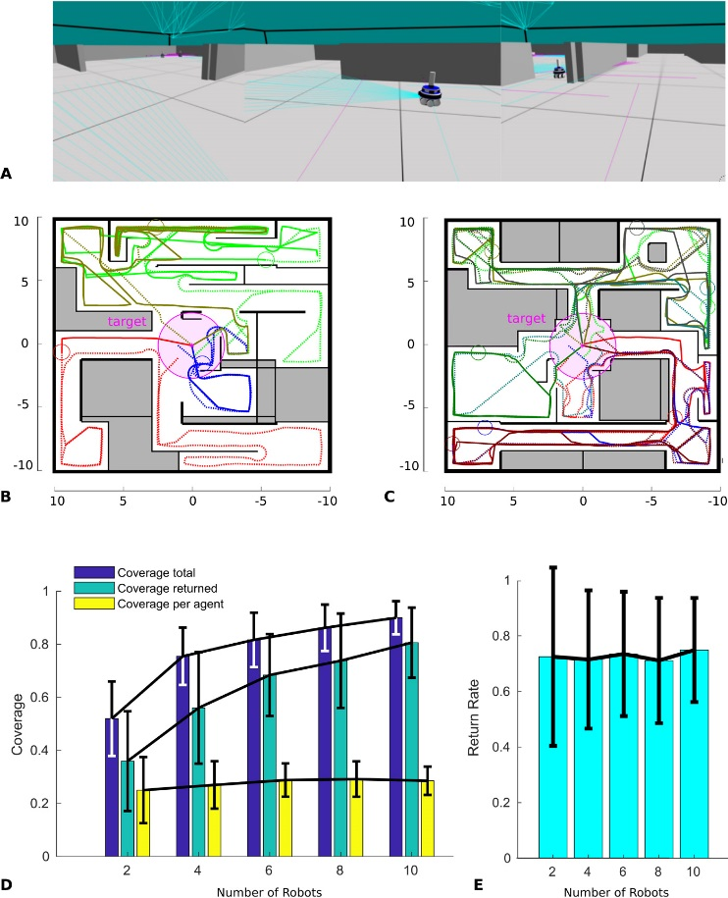1.1. Swarm Gradient Bug Algorithm

The algorithm has five primary components: movement in a given direction, wall following, odometry, inter-entity detection, and gradient based return [1]. At the start, each robot moves in a different direction to minimize overlap, and it continues moving in that direction until another robot or obstacle is encountered. When it comes near an obstacle, it moves along the outline of that obstacle until the impediment is gone. Odometry is used to determine the position of the robot, but in drones, due to vibrations and imprecise flight control, it is relatively inaccurate, so it is only used for coarse positioning. Inter-entity detection is used to prevent collisions between robots. In this work, it was accomplished by detecting the Wi-Fi transmitter signal strength on the individual drones. Finally, a gradient based return enables the robot to return to the starting point. This was done by having the drone move towards the strongest source of Wi-Fi signal in the area, which is the location from which the drones were released.

1.2. Advantages and Tradeoffs

Advantages of SGBA are that it is computationally cheap, resistant to individual robot failure [4], can work in GPS denied environments, and does not require accurate odometry [1]. This eliminate the need for powerful and heavy on-board processors that decrease the drone’s operating time.

Figure 1: ARGoS simulator results [1]. The top 2 images show the room coverage for 4 and 6 robots. The bottom left graph is a plot of total coverage, returned robot coverage, and coverage per robot for different numbers of robots. The plot on the right is a graph of the return rate of robots for different numbers of robots.

However, the lack of an internal map means a drone cannot navigate exactly from one point to another. Also, due to bandwidth limitations, video cannot be streamed back in real time, so operators must wait for drones to return before obtaining results.

2. Experimental Work

The researchers’ work has 3 main parts: computer simulation, real-life test, and application to a SAR scenario [1].

**2.1 Computer Simulation**

For initial testing, the SGBA was coded into a controller, which was then linked with Autonomous Robots Go Swarming (ARGoS), a multi-physics robot simulator, and an environment generator. As the number of robots increased, the percentage of area covered increased. With 10 robots, 90% of the rooms were searched. The area searched per robot and return rate of robots stayed mostly constant as the number of robots increased, which is because each robot can only move so fast and operate for a certain length of time, and these parameters are not affected by the presence of other robots.

**2.2 Real Life Experiment**

In this phase, researchers used the Crazyflie 2.0, a commercially available drone weighing 33 g [5], to conduct tests in an office environment. The collected results closely match that of the simulation, with the coverage area increasing and the area covered per drone staying mostly constant as the number of drones increased. However, the return rate decreased as the number of drones increased, a difference from simulation results. This is mainly due to hardware issues: as the number of drones increases, so does the possible points of failure. Also, the operating environment becomes crowded, resulting in 2 drones crashing into each other when 6 were deployed.

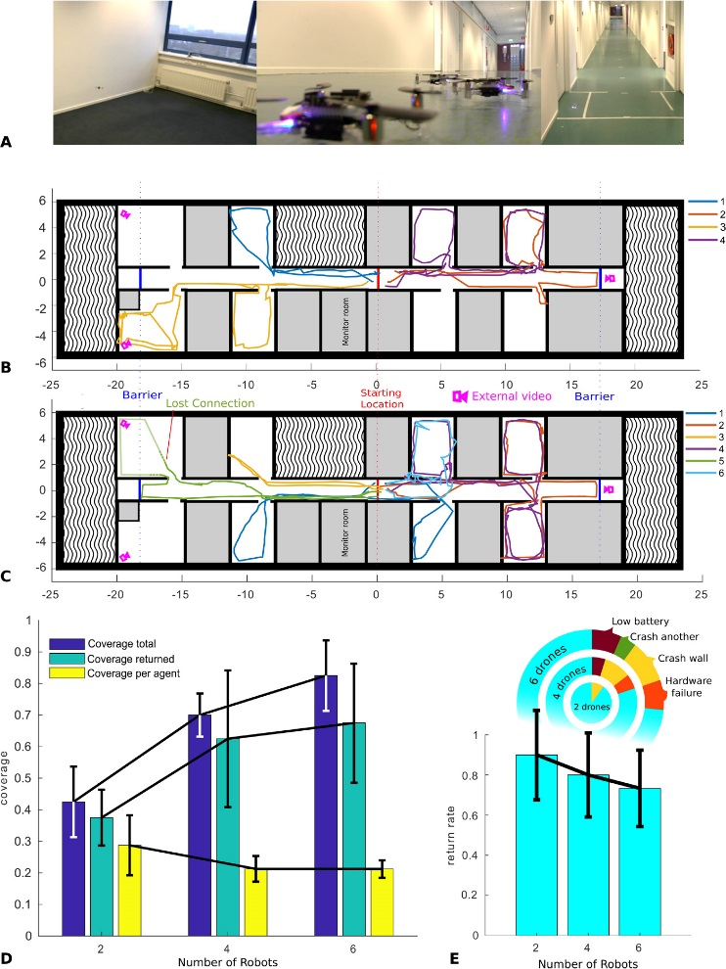

Figure 2: Real-life results of drone swarms with 2, 4, and 6 drones [1]. The graphs show the same quantities as the graphs in Figure 1, but a diagram has been added showing the failure modes of the drones.

**2.3 Search and Rescue**

Finally, a mock SAR scenario was created [1]. In the same setting as the real-life test, 2 wooden figures were placed in 2 different rooms. Within 4 minutes of releasing the drones, images of the victims were obtained. The robustness of the swarm was demonstrated when one of the drones that captured an image of the target broke down, but due to redundancy, another drone also acquired an image of the same victim and successfully returned to the starting point. Once the drones return, simultaneous localization and mapping techniques could be used to construct a map based on the recorded video [6].

**3. Concluding Remarks**

Based on the simulation and real-life results, as well as the demonstrated application to SAR, SGBA shows great potential for use in drone swarms.

**3.1 Improvements and Possible Applications**

During testing, researchers discovered a couple areas for potential future improvement. The first was the bandwidth being insufficient for the numerous drones communicating with each other, thus resulting in communication issues. One possible solution is switching to ultra wide band, which has higher bandwidth and is less susceptible to interference. Also, advances in battery storage density or processor efficiency would enable more sophisticated algorithms and/or longer drone flight times. Finally, the drone’s laser rangers could be replaced with sonar or radar for use in dusty or smoky environments [1].

However, these shortcomings do not present a significant obstacle to the widespread application of drone swarms, which are well suited for environments that are dangerous, require an unknown amount of resources, large, unstructured, and/or rapidly changing. Swarms can quickly adapt to changing situations and tolerate the loss of individual members. Thus, potential uses include, but are not limited to toxic spill cleanups, SAR, geographical exploration, reconnaissance, and disaster recover.

**3.2 Author Reactions**

I feel this work is an excellent example of biomimetics [7], where researchers recognized the successfulness of eusocial behavior and tried their best to capture it in their SGBA. I especially like their approach because it is low-cost and scalable: it uses commercially available hardware. Finally, it was clear to me that hardware seemed to be a limiting factor, as the drones could only operate with simple algorithms for about 2 minutes. Based on past trends, I am confident that over time, advances in computing power and battery storage density will enable similarly sized drones to do even more in the future.

**References**

1. McGuire KN, De Wagter C, Tuyls K, Kappen HJ, de Croon GE. [Minimal navigation solution for a swarm of tiny flying robots to explore an unknown environment](https://robotics.sciencemag.org/content/4/35/eaaw9710). Sci. Robot. 2019 Oct 23;4(35). doi:[10.1126/scirobotics.aaw9710](https://doi.org/10.1126/scirobotics.aaw9710).
2. Reid CR, Sumpter DT, Beekman M. [Optimisation in a natural system: Argentine ants solve the Towers of Hanoi](https://jeb.biologists.org/content/214/1/50). J. Exp. Biol. 2011;214:50-8. doi:[10.1242/jeb.048173](https://doi.org/10.1242/jeb.048173).
3. Mondada F, Gambardella LM, Floreano D, Nolfi S, Deneuborg JL, Dorigo M. [The cooperation of swarm-bots: physical interactions in collective robotics](https://ieeexplore.ieee.org/document/1458313). IEEE Robot. Autom. Mag. 2005;12(2):21-8. doi:[10.1109/MRA.2005.1458313](https://doi.org/10.1109/MRA.2005.1458313).
4. Dorigo M, Birattari M, Brambilla M. [Swarm robotics](http://www.scholarpedia.org/article/Swarm_robotics). Scholarpedia. 2014;9(1):1463. doi:[10.4249/scholarpedia.1463](https://doi.org/10.4249/scholarpedia.1463).
5. Bitcraze AB. [Crazyflie 2.0](https://www.bitcraze.io/crazyflie-2/). Sweden: Bitcraze AB; 2019.
6. Fuentes J, Ruiz-Ascencio J, Rendon-Mancha JM. [Visual simultaneous localization and mapping: a survey](https://link.springer.com/article/10.1007/s10462-012-9365-8). Artificial Intelligence Review. 2015 Jan;43(1):55-81. doi:[10.1007/s10462-012-9365-8](https://doi.org/10.1007/s10462-012-9365-8).
7. Hwang J, Jeong Y, Park JM, Lee KH, Hong JW, Choi J. [Biomimetics: forecasting the future of science, engineering, and medicine](https://www.ncbi.nlm.nih.gov/pmc/articles/PMC4572716/). Int. J. Nanomedicine. 2015 Sep 8;10:5701-13. doi:[10.2147/IJN.S83642](https://doi.org/10.2147/IJN.S83642).